The Annotation Review for Lighthouse

Introduction
This document describes the way how to do annotation review with existing GATE Teamware version (1.1). Since current implementation does not support manual annotation and review processes in the single workflow (project), here we explain in details how to consolidate annotations and produce the resulting annotation set, by using provided workaround.
In general, you will need to run three workflows (projects). We hope that you have already read Teamware User Guide. However, for the convenience, the relevant sections in user guide will be referenced from this document.

Create Workflow Templates
You will need to create three workflow templates [UG 4.2].
You can name templates as you wish, but here they be noted as T1, T2 and T3;
- T1 - Manual annotation only (select pre-manual gas in select annotation rules step,
2 annotators per document and anonymous annotation mode).
- T2 - Automatic annotation only with merge-gas selected
- T3 - Automatic annotation with copy-gas selected

Manual Annotation (1st project)
Now you need to create projects from workflow templates [UG 4.4].
As mentioned in introduction, you will need to create 3 projects.
Please be free to name projects as you want. Here we will call them: P1, P2 and P3.
Manual Annotation project is the first of them. We will call it P1.
Create project P1 from template T1 and run P1.
When project P1 is completed (you will be notified by email), go to Documents/Corpora and open the annotated documents [UG 3.2.2]. You should see 2 annotation sets (annotator1 and annotator2) in Annotation Editor like in Figure 1.
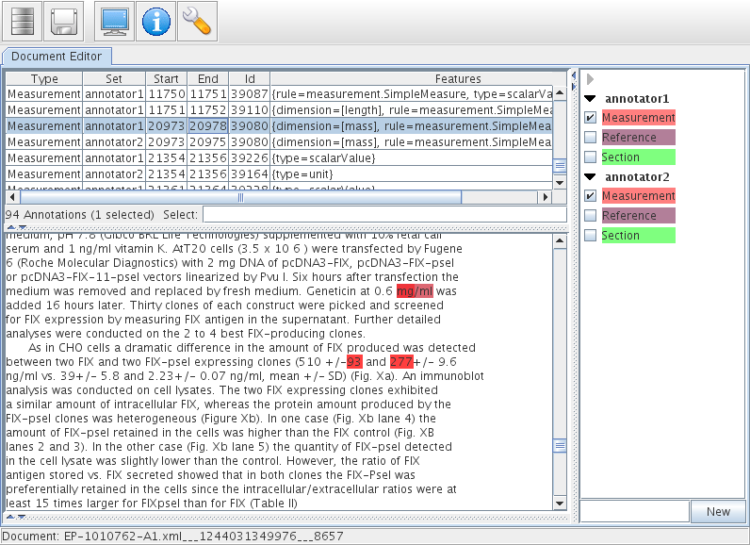
Figure 1: Document after manual annotation

Merge Annotations (2nd Project)
In order to merge annotations from annotation sets: annotator1 and annotator2, create project P2 (merge project) from T2 and run P2.
P2 (merge project):
- Copies annotator1 and annotator2 sets to annotator1.original and annotator2.original as a backup.
- Moves (copies and deletes) all annotations from annotator1 and annotator2 that are equal into consensus annotation set.

When project P2 is completed, open each doc in Annotation Editor. You should something similar to the Figure 2.
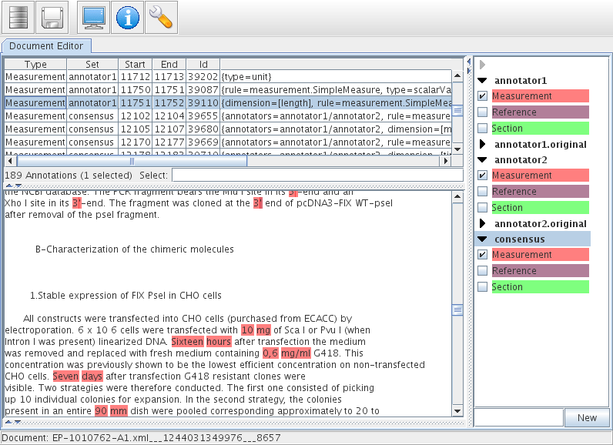
Figure 2: Document after Merge Project.

Review Annotations
While you have document opened, it is a good time to review annotations. Now you can:
- delete and/or edit any incorrect annotations in annotator1 and annotator2
- delete and/or edit any incorrect annotations in consensus set (only if you think that both annotators can make the same mistake).
Deleting annotations is very simple and it is shown in Figure 3.
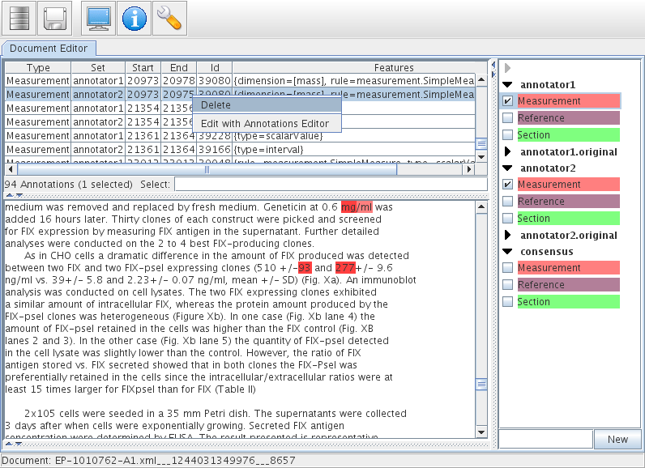
Figure 3: Delete annotations

Create the Result Annotation Set (3rd Project)
In order to make result annotation set which contains only correct annotations, create project P3 (copy project) from T3 and run P3.
P3 (copy project):
- takes all annotations remaining in annotator1 and annotator2 (not deleted by reviewer in last step) and copies them into consensus, each with a feature annotator=annotator1 or annotator=annotator2 depending on where they came from.
- adds a feature to the document accepted=true unless there are no annotations in the document.
The document will have the feature document accepted=true unless:
- either it has not gone through the final step
- or it has no annotations
As the result of the whole 3-level process you will have consensus set.

